

# RESEARCH ETHICS BOARDS

# APPLICATION FORM

**Prospective Research**

This form should only be used if new data will be collected. For research involving only secondary use of existing information (such as health records, student records, survey data or biological materials), use the *REB Application Form – Secondary Use of Information for Research.*

This form should be completed using the [*Guidance for Submitting an Application for Research Ethics Review*](https://cdn.dal.ca/content/dam/dalhousie/pdf/research-services/REB/Dal%20REB%20Application%20Instructions%20-%20Prospective%20Research%20%20v2021-02.pdf).

## SECTION 1. ADMINISTRATIVE INFORMATION [File No: office only]

|  |
| --- |
| Indicate the preferred Research Ethics Board to review this research:  [ ] Health Sciences OR [X] Social Sciences and Humanities |

|  |
| --- |
| **Project Title:** Visualizing Uncertainty with Chromatic Aberration |

|  |  |  |  |  |  |  |  |
| --- | --- | --- | --- | --- | --- | --- | --- |
| **1.1** **Research team information** | | | | | | | |
| Lead researcher  (at Dalhousie) | Name | Md Rashidul Islam | | | | | |
| Email (@dal) | md313724@dal.ca | | Phone | | | +88 01731841299 |
| Banner # | B00870359 | | Academic Unit | | | Comp Sci |
| Co-investigator names, affiliations, and email addresses | Dr. Stephen Brooks, sbrooks@cs.dal.ca | | | | | | |
| Contact person for this submission (if not lead researcher) | Name |  | | | | | |
| Email |  | | | Phone |  | |
| Study start date | Nov 5, 2021 | | Study end date | | Nov 20, 2021 | | |

|  |  |  |  |
| --- | --- | --- | --- |
| **1.2** **For student submissions** (including medical residents and postdoctoral fellows) | | | |
| Degree program | Master of Computer Science | | |
| Supervisor name and department | Dr. Stephen Brooks | | |
| Supervisor Email (@dal) | sbrooks@cs.dal.ca | Phone | 902-494-2512 |
| Department/unit ethics review (if applicable). **Undergraduate minimal risk research only**. | | | |
| Attestation: [ ] I am responsible for the unit-level research ethics review of this project and it has been approved.  Authorizing name:  Date: | | | |

|  |  |  |  |  |
| --- | --- | --- | --- | --- |
| **1.3** **Other reviews** | | | | |
| Other ethics review (if any) for this research | | Where? |  | |
| Status? |  | |
| Scholarly/scientific peer review (if any) |  | | | |
| Is this a variation on, or extension of, a previously approved Dal REB submission? | | | | [X] No  [ ] Yes Dal REB file #________________ |
| **If yes**, describe which components of the current submission are the same as the previously approved submission (list section numbers), and which components are different from the previously approved submission (list section numbers). You may also use highlighting to clearly indicate revised text. | | | | |

|  |  |  |
| --- | --- | --- |
| **1.4** **Funding**  [x] Not Applicable | | |
| Funding (list on consent form) | Agency |  |
| Award Number |  |
| Institution where funds are/will be held | [ ] Dalhousie University  [ ] Other: _____________________ |
| Was a Dal release of funds agreement issued for this award? | | [ ] Yes Date of RoF Agreement: ____________ |

|  |
| --- |
| **1.5 Attestation(s).** The appropriate boxes *must* be checked for the submission to be accepted by the REB |
| **[X]** I am the **lead researcher** (at Dalhousie) named in section 1.1. I agree to conduct this research following the principles of the Tri-Council Policy Statement *Ethical Conduct for Research Involving Humans* ([TCPS](http://www.pre.ethics.gc.ca/eng/policy-politique_tcps2-eptc2_2018.html)) and consistent with the University [*Policy on the Ethical Conduct of Research Involving Humans*](http://www.dal.ca/dept/university_secretariat/policies/human-rights---equity/ethical-conduct-of-research-involving-humans-policy.html).  I have completed the TCPS Course on Research Ethics ([CORE](http://tcps2core.ca/welcome)) online tutorial.  [X] Yes [ ] No  For Supervisors (of student / learner research projects):  **[X]** I am the **supervisor** named in section 1.2. I have reviewed this submission, including the scholarly merit of the research, and believe it is sound and appropriate. I take responsibility for ensuring this research is conducted following the principles of the [TCPS](http://www.pre.ethics.gc.ca/eng/policy-politique_tcps2-eptc2_2018.html) and University [Policy](http://www.dal.ca/dept/university_secretariat/policies/human-rights---equity/ethical-conduct-of-research-involving-humans-policy.html).  I have completed the TCPS Course on Research Ethics ([CORE](http://tcps2core.ca/welcome)) online tutorial.  [X] Yes [ ] No |

## SECTION 2. PROJECT DESCRIPTION

|  |
| --- |
| **2.1 Lay summary** |
| 2.1.1 In **plain language**, describe the rationale, purpose, study population and methods to be used. Include a summary of background information or literature to contextualize the study. What new knowledge, or public or scientific benefit is anticipated? [maximum 500 words]  In recent years, an increasing array of research has been conducted by researchers in the field of visualization in concert with time series forecasting by employing a variety of machine learning models. In this study, we investigate a novel approach for data visualization. Our aim is to simultaneously visualize both the numeric predictions from machine learning models of data over time, as well as the predictive model uncertainties.  We utilize some common and existing machine learning models to obtain the predicted results and the model uncertainties. We then visualize the data itself, but also the calculated model uncertainties with chromatic aberration in an interactive fashion. This chromatic aberration will artificially separate the Red, Green and Blue components of colors spatially in the visualization. Examples of which will appear later in this application. The effect is a particular kind of blurriness of color perception. The idea is that the more uncertainty there is in a single predicted datapoint, the more its visual representation will be affected by chromatic aberration, with the intent of conveying that sense of uncertainty to the viewer through the visual channel.  The purpose of this study is the test whether in fact chromatic aberration can be used successfully to represent uncertainty and determine how accurately viewers can estimate the degree of uncertainty based on a given level of chromatic aberration applied to representative visual elements of predicted data values. This will be determined interactively with users through a web-based visualization system. This also will involve the determination of chromatic aberration parameters to calibrate the mapping of uncertainty to the degree of chromatic aberration.  Many time series datasets could be used to explore this data visualization idea. But we decided to utilize recent data regarding the Covid 19 pandemic as we suspect there would be wide interest in the topic and the topic itself is not overly obscure with regards to the general public. We will utilize and present time series data sourced from the World Health Organization (WHO) for the most impacted countries in the world, with respect to number of new cases, total cases, mortality rates and recovery rates.  A user-based evaluation will be conducted with members from Dalhousie University community. Participants will be asked to complete various interactive tasks using different spatial arrangements and animated transitions. We will capture their performance through logging software and will record their verbal expressions, including interview responses, with computer audio recording software. After completing interactive visualization tasks, participants will fill out a questionnaire to allow us to further explore their perceptions of the technique and then we will interview the participants to obtain more feedback for future improvements.  The anticipated new knowledge will potentially be a novel method of data visualization, in particular of data uncertainty that may be applicable to a wide variety of data domains. The aim will be to produce a journal paper that will report the suitability of chromatic aberration for this purpose.  [ ] This is a pilot study.  [X ] This is a fully developed study. |
| 2.1.2 Phased review. If a phased review is being requested, describe why this is appropriate for this study, and which phase(s) are included for approval in this application. Refer to the [guidance document](https://cdn.dal.ca/content/dam/dalhousie/pdf/research-services/REB/Dal%20REB%20Application%20Instructions%20-%20Prospective%20Research%20%20v2021-02.pdf) before requesting a phased review.  [x] Not applicable |

|  |
| --- |
| **2.2** **Research question** |
| State the research question(s) or research objective(s).  The prime focus of the research is to calculate uncertainty from the forecasted results of machine learning predictive models and then represent these uncertainties in visualization in terms of chromatic aberration. In particular we will conduct:   1. A comparative evaluation of static visual uncertainty representations: our proposed chromatic aberration method, standard image blur and additive visual noise. 2. A comparative evaluation of dynamic visual uncertainty representations: our proposed chromatic aberration method against an animated variant of our proposed chromatic aberration method. |

|  |
| --- |
| **2.3** **Recruitment** |
| 2.3.1 Identify the study population. Describe and justify any inclusion / exclusion criteria. Also describe how many participants are needed and how this was determined.  The population for our study will include members of the Dalhousie University community but may extend beyond to other universities and to the general public. We also require participants to be fluent in English because there will be questionnaires and interviews.  One of the prime criterions for the selection process is to test for color-blindness of the participants. The participants must be capable to decern color in order to provide meaningful data for the study.  The study population will be at least post-secondary students or professionals who have some degree of computer experience as a user of applications. In particular, they must have some knowledge of how to use the internet because the study will be conducted online. The study program will be deployed on a server and participants need to make sure they have internet connection with their computer or laptop, and they can access and use it through their own browser.  Primarily, we have decided to pick-up around 10-15 participants for our study. It can be changed later based on the demand of the situation. <HOW MANY CONDITIONS? NEED COUNTER BALANCING?> |
| 2.3.2 Describe recruitment plans and append recruitment instruments. Describe who will be doing the recruitment and what actions they will take, including any screening procedures.  Recruitment will be conducted by the primary researcher with the close supervision of the supervisor. Due to COVID restrictions imposed by the provincial authority and for the sake of respecting health priority of Dal community, we decided to contact with the participants through email and digital messaging boards. Participants will initially be recruited through Dalhousie’s digital message boards, including Notice Digest (notice.digest@dal.ca), the Computer Science Mailing List (cs.all@dal.ca) and the Dal Students emails (dalstudent@dal.ca) and physical bulletin boards on campus. If necessary further recruits will be sought from similar message boards at other Canadian universities as well as message boards used in the data visualization community. For all monitored email lists and bulletin boards, permission will be obtained beforehand.  When potential participants respond to the recruitment notice, we will email them the inclusion criteria (English fluency, experience with computers, not color-blind) to assure that they meet the inclusion criteria. The screening email is given in Appendix ?. |
| 2.3.3 If you require permission, cooperation, or participation from a community, organization or company to recruit your participants, describe the agreement obtained from the relevant group(s). Attach correspondence indicating their cooperation and/or support (required). Describe any other community consent or support needed to conduct this research. (If the research involves Indigenous communities complete section 2.11).  [x] Not applicable |

|  |
| --- |
| **2.4** **Informed consent process** |
| 2.4.1 Describe the informed consent process:  A) How, when and by whom will the study information be conveyed to prospective participants? How will the researcher ensure prospective participants are fully informed?  Prospective participants will receive a copy of the consent letter (Appendix A) and a sample email (Appendix B) through email after they indicated an interest in participating in the study. They will be instructed to read the consent letter before giving their consent. The email will also indicate to prospective participants that they can ask clarifying questions regarding the study.  B) Describe how consent will be documented (e.g. written signature, audio-recorded, etc).  Consent will be recorded via a web survey (hosted at surveys.dal.ca).  Participants who opt not to provide consent and not to participate will receive a “Thank you” message and will not be able to proceed in the participation of the survey.  [ X ] Append copies of all consent information that will be used (e.g. written consent document, oral consent script, assent document/script, etc).  Note: If the research will involve third party consent (with or without participant assent), and/or ongoing consent, ensure these are described above. |
| 2.4.2 Discuss how participants will be given the opportunity to withdraw their participation (and/or their data) and any time (or content) limitations on this. If participants will not have opportunity to withdraw their participation and/or their data explain why.  Participants are informed in the consent form and that they can withdraw from the study at any time.  Participants can opt to withdraw their data from the study up to 2 weeks after the interview. If a participant opts to withdraw from the study, their questionnaire will be securely erased. |
| 2.4.3 If an alteration/exception to the requirement to seek prior informed consent is sought, address the criteria in TCPS article [3.7A](http://www.pre.ethics.gc.ca/eng/tcps2-eptc2_2018_chapter3-chapitre3.html#b). If the alteration involves deception or nondisclosure, also complete section 2.4.4.  [X] Not applicable |
| 2.4.4 Describe and justify any use of deception or nondisclosure and explain how participants will be debriefed.  [X] Not applicable |

|  |
| --- |
| **2.5** **Methods, data collection and analysis** |
| 2.5.1  A) Where will the research be conducted?  Research will be conducted remotely using Microsoft Teams or Skype based on the participant’s convenience. So, the participants will be able to participate in the study from their homes.  B) What will participants be asked to do?  We have developed a web application and for this reason participants do not need to install any software in his/her own machine for this study other than a communicating medium (software), for example: Skype. We will provide a URL and then participants will be asked to navigate to the application. From there they will directly access the visualizations.  They will be asked to share their screen using Skype or MS Teams to show the running application. They will then be given short interactive tasks that will give them exposure to the methods of visually representing uncertainty. The same tasks will be done with the competing uncertainty visualization methodologies. Images of the screenshots are given in Appendix C along with the Questionnaire. Each image in the questionnaire represents a major feature and for easier clarification we have added descriptions alongside. The participants need to observe and understand the features to answer questions correctly, and we will brief them to understand the contents whenever needed.  C) What data will be collected using what research instruments? (Note that privacy and confidentiality of data will be covered in section 2.6)  The following data will be collected:   * answers to the questionnaire questions (Appendix C) will be collected using Opinio at https://surveys.dal.ca/opinio/admin/folder.do * video and audio recording of screenshare session will be collected using Microsoft Teams or Skype.   D) How much of the participant’s time will participation in the study require?  Approximately 1 hours will be required. The participant should go through the presentation in dynamic web application for 1 hour and another 1 hour is anticipated for the completion of questionnaire section which is the main component of the survey.  [ ] Append copies of all research instruments (questionnaires, focus group questions, standardized measures, etc)  [ ] This is a clinical trial (physical or mental health intervention) – ensure section 2.12 is completed |
| 2.5.2 Briefly describe the data analysis plan. Indicate how the proposed data analyses address the study’s primary objectives or research questions.  There will be several aspects to data collection and analysis. First of all, we will record the audio of participants while they perform tasks; we anticipate that participants may express frustration or describe their intensions while performing the tasks. We will use this information to help interpret the log data, described next. Second, the timings of the required tasks will be recorded. Third, there will a color vision test and tasks related questionnaires to fill out by participants. Fourth, after all the tasks are finished, we will answer a questionnaire about the experience of using our application and the two selection techniques.  The timing of finishing tasks and user estimates of uncertainty will be objective quantitative measures of performance; responses to rating questionnaires will give us subjective quantitative data such as the degree of user satisfaction with the interface and confidence about finishing tasks. The data will give us information that will allow us to further refine our interface in future work.  Post-session questionnaires (Appendix C) will provide us with additional feedback, which might not be apparent in the previous data and will help us to more comprehensively understand the preference of a participant’s choices in terms of these visualization techniques. The questionnaire will ask how much they agree with the statements about each question with answer options (Strongly disagree / Somewhat agree / Neither agree nor disagree / Somewhat agree / Strongly agree). The interview results will be tabulated to provide a scoring for each question. Scoring will be conducted by assigning the following numbers to each checkbox:   * Strongly Disagree = -2 * Somewhat Disagree = -1 * Neither agree nor disagree = 0 * Somewhat agree = +1 * Strongly Agree = +2   In some cases, where the statement is negative towards the visualization method, then the scoring will be reversed. For example, “Tracing aberration is confusing” would consider “Strongly Disagree” as +2 instead of -2.  Participant responses will be compared and aggregated. Positive averaged scores for the approach will support the hypothesis that chromatic aberration is more useful for uncertainty visualization over alternatives.  Participants’ feedback is also requested in written form. This feedback, in addition to comments made by the user during the screenshare, will be used as suggestions for future work. |
| 2.5.3 Describe any compensation that will be given to participants and how this will be handled for participants who do not complete the study. Discuss any expenses participants are likely to incur and whether/how these will be reimbursed.  Every participant will receive compensation of $10 and it will be given directly from the researcher after the study. The compensation will be given even if the participant does not finish the study. Before the study, participants will sign the Participant Payment Receipt (Appendix ?), concerning the acceptance of the payment and there won’t be any other expenses in the study. |

|  |
| --- |
| **2.6** **Privacy and confidentiality** |
| 2.6.1  A) Describe who will have knowledge of participants’ identities.  Only the researcher will know the relationship between participant’s name and unique participant IDs.  B) Describe the level of identifiability of the study data (anonymous, anonymized, de-identified/coded, identifying) (see [TCPS Chapter 5A – types of information](http://www.pre.ethics.gc.ca/eng/tcps2-eptc2_2018_chapter5-chapitre5.html#a) for definitions).  Data from this study will be associated to participants IDs (Coded Information).  C) Specify which members of the research team (or others) will have access to participants’ data and for what purpose.  Project supervisor might have access on participants information for validation and justify their achievement with their qualification. In other words, to justify how much the educational background or knowledge level helps to answer the questionnaire properly.  D) Describe measures to ensure privacy and confidentiality of study documents and participant data during the data collection and analysis phase. [Note that plans for long term storage will be covered in 2.6.2]   * Address: handling of documents/data during data collection; transportation or transfer of documents/data; storage of documents/data (during the study). * If a key-code will be maintained, describe how it will be kept secure. * For electronic data, describe electronic data security measures, including file encryption and/or password protection [as applicable](https://cdn.dal.ca/content/dam/dalhousie/pdf/research-services/REB/Protecting%20Electronically%20Stored%20Personally%20Identifiable%20Research%20Data.pdf). * For hard copy documents, describe physical security measures (specify location).   We will use one of the recommended Dal online survey solutions named “Opinio” for the questionnaire. The questionnaire will include multiple choice questions and written responses to questions. Personal information from the questionnaire will be stripped to a separate file. Data will always refer to encoded Participant ID.  [ ] This research involves personal health records (ensure section 2.13 is completed) |
| 2.6.2 Describe plans for data retention and long-term storage (i.e. how long data will be retained, in what form and where). Will the data eventually be destroyed or irreversibly anonymized? If so, what procedures will be used for this? Discuss any plans for future use of the data or materials beyond the study currently being reviewed.  Survey responses will be stored in “Opinio” on the Dalhousie Servers. Recorded audio and video from the screenshare will be stored on a secure encrypted server at the Faculty of Computer Science, Dalhousie University. Since we have **limited**licenses for Opinio, access will typically be restricted to a **2-month** duration. If there need longer duration of persistency, then we must contact the proper authority for the extension. Alternately, the researcher can store another copy of the data in their own secure repositories. Only the researchers listed in the consent form will have access to the data collected in this study.  [ ] This research will be deposited in a data repository (ensure section 2.14 is completed) |
| 2.6.3  Describe if/how participant confidentiality will be protected when research results are reported:  A) For quantitative results - In what form will study data be disseminated?  [ ] Only aggregate data will be presented  [X] Individual de-identified, anonymized or anonymous data will be presented  [ ] Other. If “other”, briefly describe dissemination plans with regard to identifiability of data.  [ ] Not applicable, only qualitative data will be presented  B) For qualitative results - Will identifiable data be used in research presentations/publications? If participants will be quoted, address consent for this and indicate whether quotes will be identifiable or attributed.  [ ] Not applicable, only quantitative data will be presented  Participants are given the option to allow/disallow the researchers to use quotes when disseminating results in the consent form. These quotes would be collected from the written questions in the questionnaire (Appendix C) and from the recorded audio capture during the user study. We will use participant IDs for quotes. |
| 2.6.4 Address any limits on confidentiality, such as a legal duty to report abuse or neglect of a [child](https://novascotia.ca/coms/families/changestoCFSA/Duty-to-Report.pdf) or [adult in need of protection](https://nslegislature.ca/sites/default/files/legc/statutes/adult%20protection.pdf), and how these will be handled. Ensure these are clear in the consent documents. (See the [guidance document](https://cdn.dal.ca/content/dam/dalhousie/pdf/research-services/REB/Dal%20REB%20Application%20Instructions%20-%20Prospective%20Research%20%20v2021-02.pdf) for more information on legal duties and professional codes of ethics).  [X] Not applicable |
| 2.6.5 Will any information that may reasonably be expected to identify an individual (alone or in combination with other available information) be accessible outside Canada? And/or, will you be using any electronic tool (e.g. survey company, software, data repository) to help you collect, manage, store, share, or analyze personally identifiable data that makes the data accessible from outside Canada?  [X] No  [ ] Yes. If yes, refer to the University [*Policy for the Protection of Personal Information from Access Outside Canada*](http://www.dal.ca/dept/university_secretariat/policies/governance/protection-of-personal-information-policy-.html), and describe how you comply with the policy (such as securing participant consent and/or securing approval from the Vice President Research and Innovation). |

|  |
| --- |
| **2.7 Risk and benefit analysis** |
| 2.7.1 Discuss what risks or discomforts are anticipated for participants, how likely risks are and how risks will be mitigated. Address any particular ethical vulnerability of your study population. Risks to privacy from use of identifying information should be addressed. If applicable, address third party or community risk. (If the research involves Indigenous communities also complete section 2.11)  The use of publicly available data surrounding Covid 19 may cause some degree of discomfort to some participants, given that the data is representative of a pandemic which is of concern to all.  In addition, it is possible the use of simulated chromatic aberration may cause some minor eye strain.  Beyond the above noted concerns, there are no anticipated physical, mental, economic or social risks associated with participation beyond those associated with everyday computer use. There may be some minor discomforts for participants in that they will be using a new software application for the first time if someone didn’t have the similar experience. We do not anticipate that this will exceed the usual levels of ambiguity or confusion commonly experienced when someone uses new software for the first time. |
| 2.7.2 Identify any direct benefits of participation to participants (other than compensation), and any indirect benefits of the study (e.g. contribution to new knowledge).  Participating in the study might benefit participants in terms of knowledge which will help them to participate in paid surveys in future, or conduct and contribute their own survey if ever required. |

|  |
| --- |
| **2.8 Provision of results to participants and dissemination plans.** |
| 2.8.1 The TCPS encourages researchers to share study results with participants in appropriate formats. Describe your plans to share study results with participants and discuss the process and format.  Participants are given a chance to add their e-mail address to receive the results of this study when it has been accepted for publication. Those participants that provided their email addresses for this purpose will receive a summary of the findings after the results are published but nobody will know other participants information. |
| 2.8.2 If applicable, describe how participants will be informed of any material incidental findings – a discovery about a participant made in the course of research (screening or data collection) that is outside the objectives of the study, that has implications for participant welfare (health, psychological or social). See [TCPS Article 3.4](http://www.pre.ethics.gc.ca/eng/tcps2-eptc2_2018_chapter3-chapitre3.html) for more information.  [ X ] Not applicable |
| 2.8.3 Describe plans for dissemination of the research findings (e.g. conference presentations, journal articles, public lectures etc.).  Results from this study will be used for the lead researcher’s MCS thesis paper and possibly for publication in Computer Science journals or conferences or in final thesis defense. |

|  |
| --- |
| * 1. Research Team |
| 2.9.1 Describe the role and duties of all research team members (including students, RA’s and supervisors) in relation to the overall study.  Dr. Brooks is a faculty member (Professor) in Computer Science. He will provide his thoughtful insights during the study trials and will take part in proper analysis after the event. Investigator Rashidul Islam has developed the study design under the direction of Dr. Brooks. This study is an integral part of his MCS Thesis component. |
| * + 1. Briefly identify any previous experience or special qualifications represented on the team relevant to the proposed study (e.g., professional or clinical expertise, research methods, experience with the study population, statistics expertise, etc.).   Dr. Brooks has previous experience in designing and executing user studies in the field of data visualization. Investigator Rashidul Islam is novice in conducting such user studies. |

|  |
| --- |
| **2.10 Conflict of interest** |
| Describe whether any dual role or conflict of interest exists for any member of the research team in relation to potential study participants (e.g. TA, fellow student, teaching or clinical relationship), and/or study sponsors, and how this will be handled.  [ X ] Not applicable |

|  |
| --- |
| 2.11 Research involving Indigenous peoples  Consult TCPS [Articles 9.1 and 9.2](http://www.pre.ethics.gc.ca/eng/tcps2-eptc2_2018_chapter9-chapitre9.html) in determining whether this section is applicable to your research.  [ X ] Not applicable – go to 2.12 |
| 2.11.1 If the proposed research is expected to involve people who are Indigenous, describe the plan for community engagement (per TCPS Articles [9.1 and 9.2](http://www.pre.ethics.gc.ca/eng/tcps2-eptc2_2018_chapter9-chapitre9.html#c)). If community engagement is not sought, explain why the research does not require it, referencing TCPS article 9.2. |
| 2.11.2 State whether ethical approval has been or will be sought from [Mi’kmaw Ethics Watch](https://www.cbu.ca/indigenous-affairs/mikmaw-ethics-watch/) and if not, why the research does not fall under their purview. If the research falls under the purview of other Indigenous ethics groups, state whether ethical approval has been or will be sought. |
| 2.11.3 Describe plans for returning results to the community and any intellectual property rights agreements negotiated with the community with regard to data ownership (see also 2.11.4 if applicable). Append applicable research agreements. |
| 2.11.4 Does this research incorporate OCAP (Ownership, Control, Access, and Possession) principles as described in TCPS [Article 9.8](https://ethics.gc.ca/eng/tcps2-eptc2_2018_chapter9-chapitre9.html#8)?  [ ] Yes. Explain how.  [ ] No. Explain why not. |

|  |
| --- |
| **2.12** **Clinical trials**  [ X ] Not applicable – go to 2.13 |
| 2.12.1 Will the proposed clinical trial be registered?  [ ] No. Explain why not.  [ ] Yes. Indicate where it was/will be registered and provide the registration number. |
| 2.12.2 If a novel intervention or treatment is being examined, describe standard treatment or intervention, to indicate a situation of clinical equipoise exists (TCPS [Chapter 11](http://www.pre.ethics.gc.ca/eng/tcps2-eptc2_2018_chapter11-chapitre11.html)). If placebo is used with a control group rather than standard treatment, please justify. |
| 2.12.3 Clearly identify the known effects of any product or device under investigation, approved uses, safety information and possible contraindications. Indicate how the proposed study use differs from approved uses.  [ ] Not applicable |
| 2.12.4 Discuss any plans for blinding/randomization. |
| 2.12.5 What plans are in place for safety monitoring and reporting of new information to participants, the REB, other team members, sponsors, and the clinical trial registry (refer to TCPS [Articles 11.6, 11.7, 11.8](http://www.pre.ethics.gc.ca/eng/tcps2-eptc2_2018_chapter11-chapitre11.html))? These should address plans for removing participants for safety reasons, and early stopping/unblinding/amendment of the trial. What risks may arise for participants through early trial closure, and how will these be addressed? Are there any options for continued access to interventions shown to be beneficial? |

|  |
| --- |
| **2.13** **Use of personal health information**  [ X ] Not applicable – go to 2.14 |
| 2.13.1 Research using health information may be subject to Nova Scotia’s [*Personal Health Information Act*](http://novascotia.ca/dhw/phia/). Describe the personal health information ([definition explained in the guidance document](https://cdn.dal.ca/content/dam/dalhousie/pdf/research-services/REB/Dal%20REB%20Application%20Instructions%20-%20Prospective%20Research%20%20v2021-02.pdf)) required and the information sources, and explain why the research cannot reasonably be accomplished without the use of that information. Describe how the personal health information will be used, and in the most de-identified form possible. |
| 2.13.2 Will there be any linking of separate health data sets as part of this research?  [ ] No  [ ] Yes  If yes:  A) Why is the linkage necessary?  B) Describe how the linkage will be conducted (it is helpful to append a flow diagram)  C) Does that linkage increase the identifiability of the participants? |
| 2.13.3 Describe reasonably foreseeable risks to privacy due to the use of personal health information and how these will be mitigated. |

|  |
| --- |
| **2.14** **Data Repositories**  [ X ] Not applicable |
| 2.14.1 Identify and describe the data repository in which the research data will be deposited. What is its focus, who are its target users, who can access deposited data and under what circumstances? For how long will the data be kept in the repository? |
| 2.14.2 Describe the data set to be released to the repository. If there is personal and/or sensitive information in the data, describe how you will prepare the data for submission to the repository and mitigate risks to privacy. Identify all fields that will be included in the final data set (include as an appendix). |
| 2.14.3 Is agreeing to have one’s data deposited a requirement for participation in the study? If yes, provide a justification. If no, indicate how participants can opt in or out. |

## SECTION 3. APPENDICES

**Appendices Checklist.** Append all relevant material to this application in the order they will be used. This may include:

[ ] Reference list

[ ] Permission or support/cooperation letters (e.g. Indigenous Band Council, School Board, Director of a long-term care facility, anyone whose permission you need to conduct recruit participants or conduct research)

[ ] Research agreements (required for research involving Indigenous communities)

[ X ] Recruitment documents (posters, oral scripts, online postings, invitations to participate, etc.)

[ ] Screening documents

[ X ] Consent/assent documents or scripts

[ X ] Research instruments (questionnaires, interview or focus group questions, etc.)

[ ] Debriefing and/or study results templates

[ ] List of data fields included in data repository

[ ] Confidentiality agreements

**Consent Form Templates**

Sample consent forms are provided on the [Research Ethics website](https://www.dal.ca/dept/research-services/responsible-conduct-/research-ethics-/resources-.html) and may be used in conjunction with the information in the [*Guidance*](https://cdn.dal.ca/content/dam/dalhousie/pdf/research-services/REB/Dal%20REB%20Application%20Instructions%20-%20Prospective%20Research%20%20v2021-02.pdf) document to help you develop your consent form.



Appendix A – Consent Form

**CONSENT FORM**

**Project title**: Visualizing Uncertainty with Chromatic Aberration

**Lead researcher**: Md Rashidul Islam, Dalhousie University, md313724@dal.ca, +8801731841299

**Other researchers**   
Dr. Stephen Brooks, [sbrooks@cs.dal.ca](mailto:sbrooks@cs.dal.ca)

**Funding provided by:** NIL

**Introduction**

We invite you to take part in a research study being conducted by Rashidul Islam, who is an MCS (Master of Computer Science) student at Dalhousie University. Choosing whether or not to take part in this research is entirely your choice. There will be no impact to you if you decide not to participate in the research. The information below tells you about what is involved in the research, what you will be asked to do and about any benefit, risk, inconvenience or discomfort that you might experience.   
  
You should discuss any questions you have about this study with Rashidul Islam or Dr. Stephen Brooks. Please ask as many questions as you have and we will be happy to answer your questions. If you have questions later, please contact Rashidul Islam.

**Purpose and Outline of the Research Study**The aim of this study is to obtain feedback on the visualization of uncertainty in predicted data. The researcher introduce and guide the participant during the process. After interacting with the system, participants will answer a questionnaire. This is based on the interactions with the web based visualization to evaluate its effectiveness and to provide general feedback. There will be multiple choice questions where the answers are in a form that asks to what extent the participant agrees or disagrees. For example: Strongly agree, strongly disagree, Partially Agree and so on.

**Who Can Take Part in the Research Study**Anyone can participate in this study who has basic knowledge for recognizing simple shapes such as circles, rectangles, ellipse, partial filling of circles etc. They also need to have access to a computer browser; for instance: Chrome, have good internet connection, and have a microphone connected to the computer to communicate with researcher. In addition participants must have color vision and not be impaired by color blindness.

**What You Will Be Asked to Do**If you decide to participate in this research, you will be asked to navigate to a web application through your computer browser. You will be asked to connect to a meeting with an audio connection. You will be recommended to close all other applications besides the navigated application and the communication software itself. You will be requested to share your screen with the researcher so that he can help you whenever needed.

You will be asked to select and view each sections images <do you mean they won’t work with the application but only look at images?> and corresponding description. Upon completion of viewing the notes/images, you will be asked if you have any questions regarding the content or anything is unclear, then researcher can explain you by going through the corresponding section until you are satisfied with the answers.

**Possible Benefits, Risks and Discomforts**

Benefits: A potential benefit could be that you will interact with new types of visualizations.

Risks: Looking at images that contain colors that are blurry may produce some eye strain. Also, the data used in the examples are country level Covid 19 statistics which may cause some concern for some participants. Beyond these noted potential minor issues, no significant risks are anticipated with this study beyond being bored or fatigued, or confused by using a new piece of software just like what you may feel for using any other new software. To reduce these discomforts, we will offer you breaks between activities whenever you need.

During the user study, you need to share your screen and audio with the researcher. For future use, your screen and conversation might be recorded.

**Compensation / Reimbursement**Every participant will receive compensation of $10 <need to figure out how to do this online> and it will be given directly from the researcher after the study. The compensation will be given even if the participant does not finish the study.

**How your information will be protected:**Before starting the study we will inform you that your screenshare, questionnaire/answers, conversation will be recorded for future use and these information will be stored by the research team and only they will know about your participation information.

The information that we will take from you will remain highly confidential and secure. Only the research team at Dalhousie university who work with us have access to this information and all of us have an obligation to keep all these study information protected from any kind of unauthorized access. Your identity information (name and contact information) also be securely stored separately in an encoded approach. Instead of using your name or contact information, we will create a new ID number by encrypting your base information and which will be used as your participation number. In addition to that, all information will be kept secure in an encrypted file on the researcher’s password-protected computer, and we will not maintain any paper/printed documents.

Since the study is a core component of our thesis research, we will explain and share our findings in the researcher’s thesis report and thesis’s defense. But the report will not include any individual information but group results. This means that nobody will be able to identify a single participant’s information from our reports.

No information about your participation will be disclosed by us unless it requires by law or our professional obligations. If you inform us about abuse any kind of information, we are required by law to contact authorities. If we notice that you are at an immediate risk of harming yourself or other people, we will definitely and instantly seek for assistance from proper authority by our professional code of ethics so that they can take necessary steps for the remedy.

You will be given a choice in the questionnaire form to either allow or not allow your written feedback to be quoted and collected from the form in use. You can opt-in and opt-out of having your quotes used as part of the disseminating results of this study in our reports.

We will delete your all-personal information from our repositories once the study is completed. Only questionnaire information and answers will be stored in our repositories where any personal identifying information will be cleaned up. Despite these measures, we cannot guarantee your anonymity or cannot ensure how/who will use those data in which way.

**If You Decide to Stop Participating**You are fully free to leave the study at any time. If you want to stop participating during the study, you can also decide whether you want to allow us to use or remove any of the information that you have given us up to that point. If you want not to keep your participation in the study after completing the study and want us to remove your data, then you can decide for up to 1 week. After that time, it will be impossible for us to remove your data because at that time it will be anonymized and so there will be no way to trace your data.

**How to Obtain Results**At the end of the study, we will provide you with a short description of group results but not individual results. Even if you want to get individual results then we cannot provide it due to the anonymity issue. You can obtain these results by providing your contact information at the time of participation.

**Questions**You are always welcome to reach out us with whatever questions or concerns you may have about your participation in this research study. Please contact at any time to Md Rashidul Islam at +8801731841299, md313724@dal.ca or Dr. Stephen Brooks at sbrooks@dal.ca with your questions, suggestions, comments, or concerns about the research study.

If you have any ethical concerns about your participation in this research, you may also contact Research Ethics, Dalhousie University at (902) 494-3423, or email: ethics@dal.ca (and reference REB file # 20XX-XXXX).

**Signature**Signatures will not be required as part of this informed consent process. Downloading and running the application and communicating with researcher is taken as an implied consent.

Good day Everyone,

Appendix B – Sample Email

We are recruiting participants to take part in the research study of Master of Computer Science, Dalhousie University. The user study aims to get user feedback on the visualization of uncertainty in a web based application. A potential benefit could be that A potential benefit could be that you will interact with new types of visualizations.

This study consist of a single session and will be conducted completely online to ensure participants and researcher safety and respect the imposed special measures during the COVID-19 pandemic. We created a dynamic web application that allows testing and evaluating various features related to our visualizations. After an initial privacy check, the participant will be requested to browse the application from their own computer and share their screen with the researcher while using it. With the help of screen and audio sharing, participants will be given an introduction to the system by the researcher, answering any questions they might have.

The web application will present different methods of visualizing uncertainty in data. Participants will be accessing the application from their own computer, and they will be able ask any question that arises to the researcher will remain connected online with the participant.

After reviewing and interacting with the application, the participant is provided with a questionnaire which asks for feedback on each proposed method of visualizing uncertainty in data. A series of statements are provided about each visualization feature with multiple choice questions and the participant decides by choosing one of them to represent what extent they agree with the statement. For each visualization, the participant is also provided an opportunity to provide a written feedback to the researchers. After completing these sections, the participant is provided an opportunity to provide a general but holistic written feedback at the end of the questionnaire module.

<Add information about the length of the session>

The following requirements are necessary for participation to qualify as participant in the study:

* You must have a computer with internet connection suitable to audio-video conferencing and must be willing to share your screen with the researcher and allow to record it.
* You must be able to install required software such as MS-Teams or Skype for conversation.
* You must be able browse the application and use it.
* You must have full color vision without color blindness.

Compensation is $10 for participation in the study.

Thank you for your consideration. If you agree to participate, please contact the main researcher at [md313724@dal.ca](mailto:md313724@dal.ca) for a list of potential time slots to schedule the session.

Thank you,

Md Rashidul Islam  
+8801731841299  
MCS Student  
Dalhousie University  
6299 South St, Halifax, NS B3H 4R2

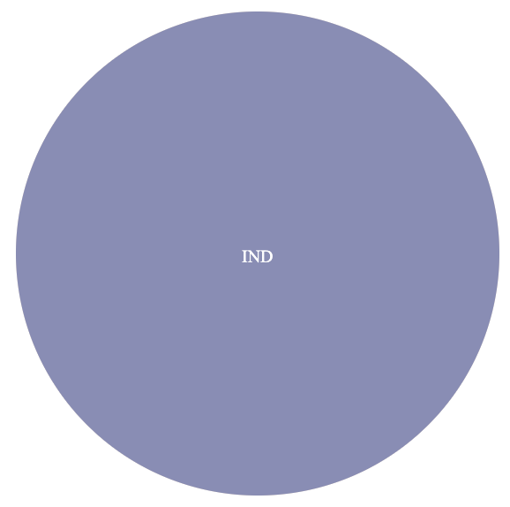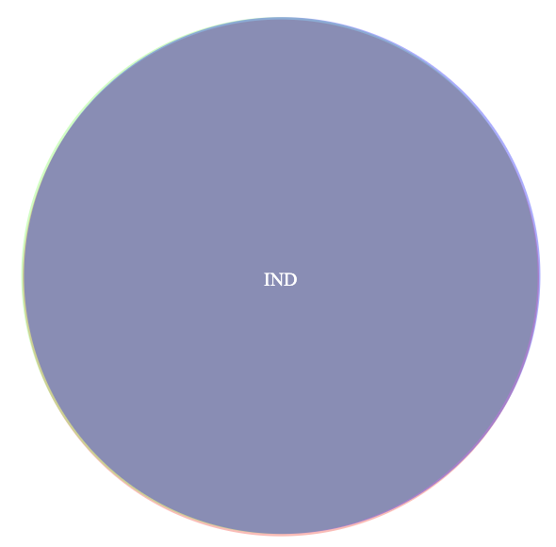

Figure-A: Color-blindness test

1. Participant will be asked to identify which circle contains colorful edge to represent chromatic aberration. To be success, s/he must answer the question correctly.

**QUESTIONNAIRE MODULE**

Appendix C – Questionnaire Module

**Project title**: Visualizing Uncertainty with Chromatic Aberration

**Lead researcher**: Md Rashidul Islam, Dalhousie University, md313724@dal.ca, +8801731841299

**Other researchers**   
Dr. Stephen Brooks, [sbrooks@cs.dal.ca](mailto:sbrooks@cs.dal.ca)

**Funding provided by:** NIL

ADD NOTE ABOUT DISPLAY SIZE AS PER RITA ORJI

Display size is another good point.    This will be an online study because of potential covid complications.   We have some zooming functionality already built in.    But we should also test it out on multiple monitors beforehand and record the monitor sizes of users as well.

color-blindness restriction

**Questions**

1. **Do you consent to the researchers quoting text you write in feedback sections below?**

Yes, I consent to my written feedback in this questionnaire being quoted anonymously.

No, I do not consent to my written feedback in this questionnaire being quoted.

**Application Overview**

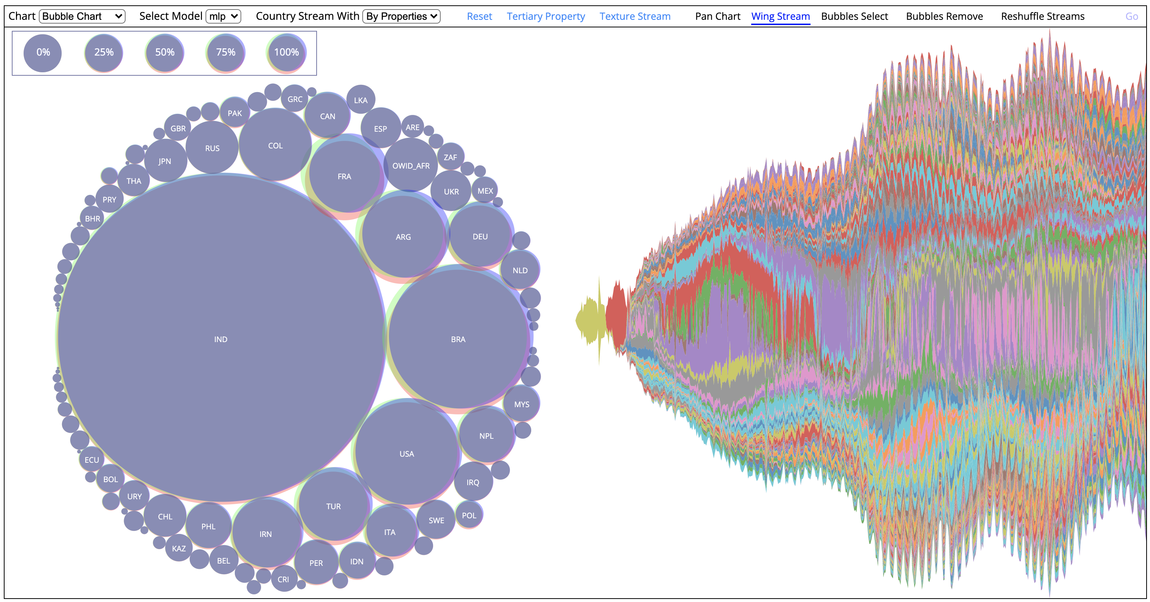

Appendix C – Questionnaire Module

Figure-1: Overview screen

**<NOTE, I would start with the most simple visualizations first, not this one>**

**Description**: At the top of the Figure-1, we see there is a toolbar with many input fields that are used to draw different types of charts and for allowing user to perform different activities like zooming, panning, filtering, selecting/deselecting bubbles to redraw bubble-chart (left) and stream-chart(right). In the bubble chart the colorful edges for each circle represents the Chromatic Aberration which will be shown more clearly in later images with smaller number of countries(bubbles). In this view, we have drawn both charts for top 100 countries having maximum number of COVID infections, so they look a bit clumsy. At the top of the bubble chart that shows percentage of uncertainties for the drawn bubbles.

**2. Select the degree to which you agree or disagree with each of the following statements:**

1. The overview screen of VUWCA is a bit incongruous due to excessive components

|  |  |  |  |  |
| --- | --- | --- | --- | --- |
| Strongly  agree | Partially  agree | Neither agree nor disagree | Partially  disagree | Strongly  disagree |

1. Uses of the percentage is confusing

|  |  |  |  |  |
| --- | --- | --- | --- | --- |
| Strongly  agree | Partially  agree | Neither agree nor disagree | Partially  disagree | Strongly  disagree |

**3. Please provide any additional comments/suggestions you wish the researchers to inform regarding this section.**

Appendix C – Questionnaire Module

……………………………………….……………………………………….……………………………………….…………………………………

……………………………………….……………………………………….……………………………………….…………………………………

……………………………………….……………………………………….……………………………………….…………………………………

**VUWCA for single Country**

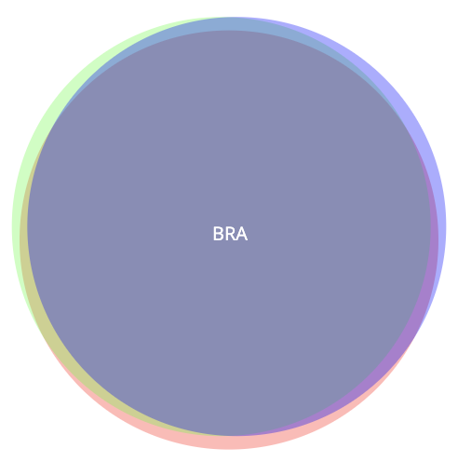

Figure-2: Bubble chart for Single country

**Description:** In Figure-2, we see a single bubble only but the surrounding colorful edges beautiful and crystal clear for normal user view. That colorful portion of the circle represents the area of uncertainty which call here as Chromatic Aberration.

**4. Select the degree to which you agree or disagree with each of the following statements:**

1. The colorful chromatic aberration is clearer than overview screen.

|  |  |  |  |  |
| --- | --- | --- | --- | --- |
| Strongly  agree | Partially  agree | Neither agree nor disagree | Partially  disagree | Strongly  disagree |

1. The thickness of the aberrated area is roughly one tenth compared to the radius of the circle.

|  |  |  |  |  |
| --- | --- | --- | --- | --- |
| Strongly  agree | Partially  agree | Neither agree nor disagree | Partially  disagree | Strongly  disagree |

1. There is no gradual blurring of colorful edge.

|  |  |  |  |  |
| --- | --- | --- | --- | --- |
| Strongly  agree | Partially  agree | Neither agree nor disagree | Partially  disagree | Strongly  disagree |

1. There are six different colors shown in edges.

|  |  |  |  |  |
| --- | --- | --- | --- | --- |
| Strongly  agree | Partially  agree | Neither agree nor disagree | Partially  disagree | Strongly  disagree |

1. The color choices help to determine the uncertainty representing area in the visualization.

|  |  |  |  |  |
| --- | --- | --- | --- | --- |
| Strongly  agree | Partially  agree | Neither agree nor disagree | Partially  disagree | Strongly  disagree |

**5. Please provide any additional comments/suggestions you wish the researchers to inform regarding this section.**

……………………………………….……………………………………….……………………………………….…………………………………

……………………………………….……………………………………….……………………………………….…………………………………

……………………………………….……………………………………….……………………………………….………………………………

**VUWCA for three Countries**

Appendix C – Questionnaire Module

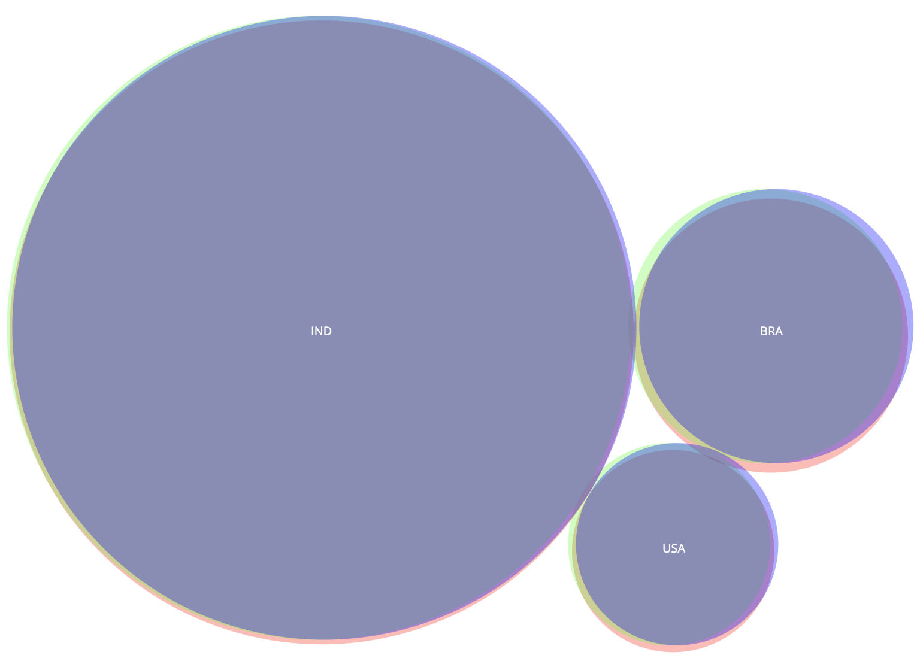

Figure-3: Bubble chart with three countries

**Description:** This chart is drawn with three countries only to gradually introduce the difference to the user. Since Figure-2 had only one country so there was nothing to compare side by side but here in Figure-3 user can compare both uncertainty and number of infections count.

**6. Select the degree to which you agree or disagree with each of the following statements:**

1. Brazil (BRA) shows maximum uncertainty among three.

|  |  |  |  |  |
| --- | --- | --- | --- | --- |
| Strongly  agree | Partially  agree | Neither agree nor disagree | Partially  disagree | Strongly  disagree |

1. United States (USA) gets second maximum uncertainty among three.

Appendix C – Questionnaire Module

|  |  |  |  |  |
| --- | --- | --- | --- | --- |
| Strongly  agree | Partially  agree | Neither agree nor disagree | Partially  disagree | Strongly  disagree |

1. India (IND) got maximum number of infections.

|  |  |  |  |  |
| --- | --- | --- | --- | --- |
| Strongly  agree | Partially  agree | Neither agree nor disagree | Partially  disagree | Strongly  disagree |

1. Brazil (BRA) has second maximum number of infections.

|  |  |  |  |  |
| --- | --- | --- | --- | --- |
| Strongly  agree | Partially  agree | Neither agree nor disagree | Partially  disagree | Strongly  disagree |

1. Based on Figure-3 uncertainty is irrelevant to the number of infections because India has maximum count but not maximum uncertainty.

|  |  |  |  |  |
| --- | --- | --- | --- | --- |
| Strongly  agree | Partially  agree | Neither agree nor disagree | Partially  disagree | Strongly  disagree |

**7. Please provide any additional comments/suggestions you wish the researchers to inform regarding this section.**

……………………………………….……………………………………….……………………………………….…………………………………

……………………………………….……………………………………….……………………………………….…………………………………

……………………………………….……………………………………….……………………………………….…………………………………

**VUWCA for Ten Countries**

Appendix C – Questionnaire Module

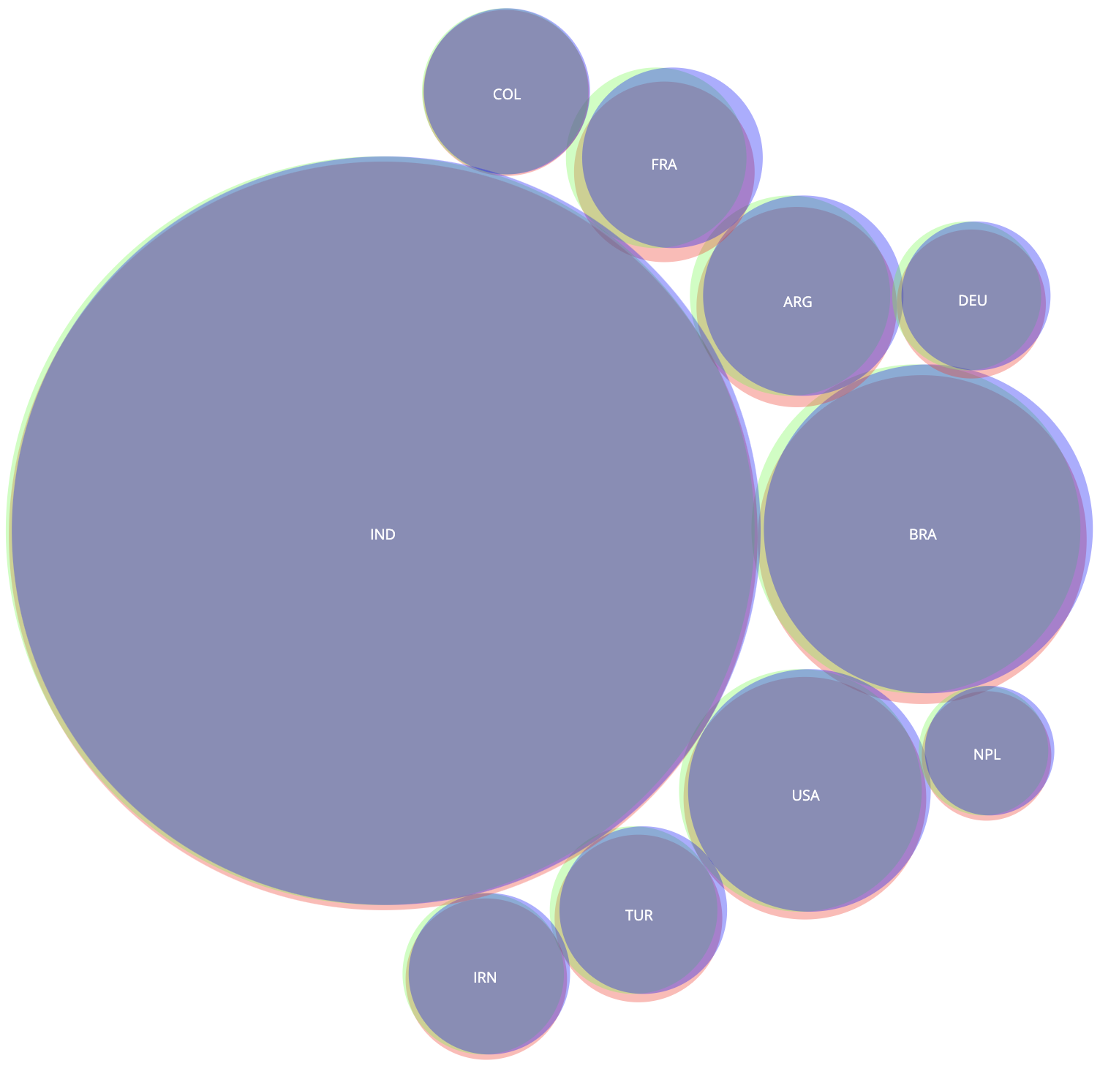

Figure-4: Bubble chart with ten countries

**Description:** This is an extended version of Figure-3 where we have used data for 10 countries. All three countries from the earlier Figure-3 are also here but the order of uncertainties has been changed and that is especially noticeable here.

**8. Select the degree to which you agree or disagree with each of the following statements:**

Appendix C – Questionnaire Module

1. France (FRA) shows maximum uncertainty among tens.

|  |  |  |  |  |
| --- | --- | --- | --- | --- |
| Strongly  agree | Partially  agree | Neither agree nor disagree | Partially  disagree | Strongly  disagree |

1. Colombia (COL) shows minimum uncertainty among tens.

|  |  |  |  |  |
| --- | --- | --- | --- | --- |
| Strongly  agree | Partially  agree | Neither agree nor disagree | Partially  disagree | Strongly  disagree |

1. Uncertainty of Argentina (ARG) and Brazil (BRA) are ambiguous in terms of maximum value.

|  |  |  |  |  |
| --- | --- | --- | --- | --- |
| Strongly  agree | Partially  agree | Neither agree nor disagree | Partially  disagree | Strongly  disagree |

1. Though uncertainties are similar, but Brazil (BRA) has more infections count than Argentina (ARG).

|  |  |  |  |  |
| --- | --- | --- | --- | --- |
| Strongly  agree | Partially  agree | Neither agree nor disagree | Partially  disagree | Strongly  disagree |

1. United States (USA), Germany (DEU) and Turkey (TER) have similar uncertainty values.

|  |  |  |  |  |
| --- | --- | --- | --- | --- |
| Strongly  agree | Partially  agree | Neither agree nor disagree | Partially  disagree | Strongly  disagree |

1. Still in Figure-4 uncertainty is irrelevant to the number of infections of the countries.

|  |  |  |  |  |
| --- | --- | --- | --- | --- |
| Strongly  agree | Partially  agree | Neither agree nor disagree | Partially  disagree | Strongly  disagree |

**9. Please provide any additional comments/suggestions you wish the researchers to inform regarding this section.**

Appendix C – Questionnaire Module

……………………………………….……………………………………….……………………………………….…………………………………

……………………………………….……………………………………….……………………………………….…………………………………

……………………………………….……………………………………….……………………………………….…………………………………

**VUWCA for 100 Countries**

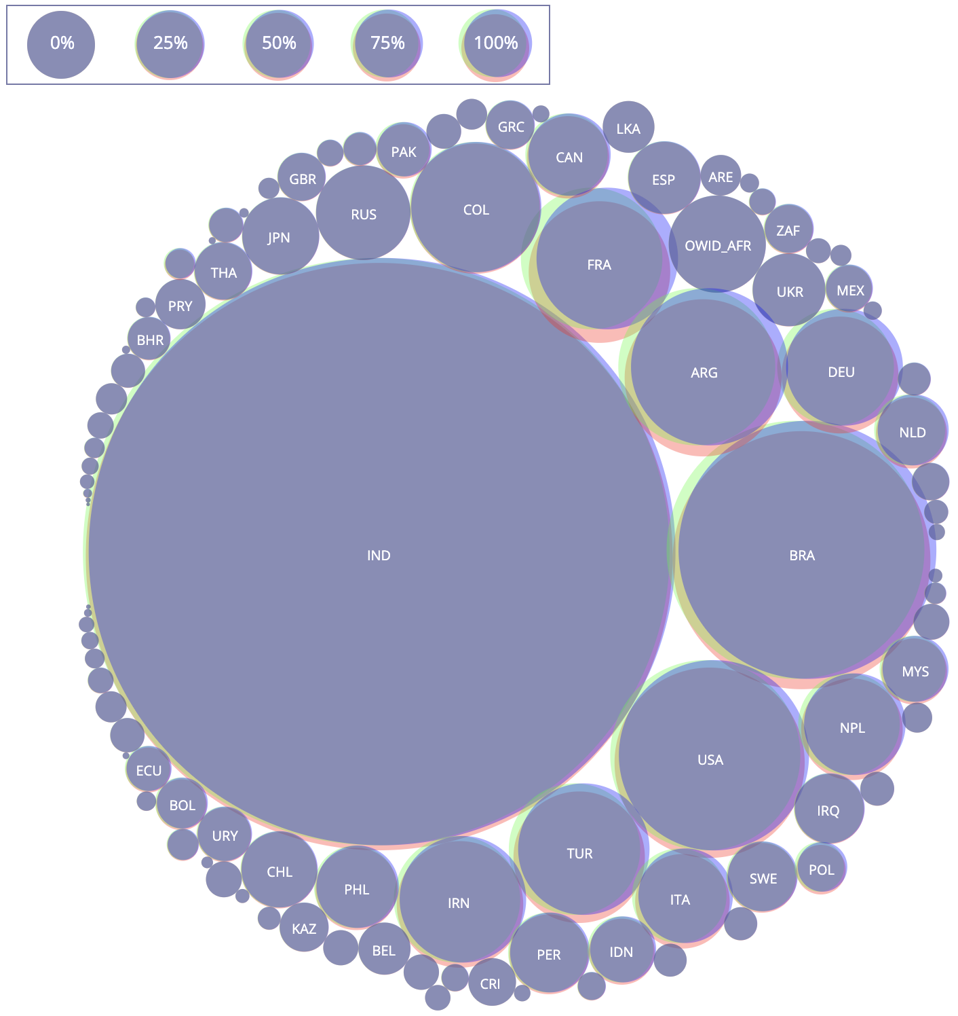

Figure-4: Bubble chart for 100 countries

**Description:** We have trained the machine learning models for top 100 countries based on the number of infections. In this Figure-4, we have utilized data for all countries. Since the chart is zoomable, we have not shown label for the smaller circumference countries due to insufficient space to accommodate and can be zoomed-in to see the corresponding label of the country. We are skipping those countries to make any question regarding them.

**10. Select the degree to which you agree or disagree with each of the following statements:**

1. France (FRA) shows maximum uncertainty.

|  |  |  |  |  |
| --- | --- | --- | --- | --- |
| Strongly  agree | Partially  agree | Neither agree nor disagree | Partially  disagree | Strongly  disagree |

1. Quite impossible to find the minimum uncertainty country.

|  |  |  |  |  |
| --- | --- | --- | --- | --- |
| Strongly  agree | Partially  agree | Neither agree nor disagree | Partially  disagree | Strongly  disagree |

1. Second and third largest uncertainty countries are still confusing.

|  |  |  |  |  |
| --- | --- | --- | --- | --- |
| Strongly  agree | Partially  agree | Neither agree nor disagree | Partially  disagree | Strongly  disagree |

1. United States (USA) has higher uncertainty than Turkey (TUR)

|  |  |  |  |  |
| --- | --- | --- | --- | --- |
| Strongly  agree | Partially  agree | Neither agree nor disagree | Partially  disagree | Strongly  disagree |

1. Difficult to justify with naked eye if some countries have uncertainties like Kazakhstan (KAZ).

|  |  |  |  |  |
| --- | --- | --- | --- | --- |
| Strongly  agree | Partially  agree | Neither agree nor disagree | Partially  disagree | Strongly  disagree |

1. All countries still maintain the irrelevance of uncertainty with number of infections of the countries.

|  |  |  |  |  |
| --- | --- | --- | --- | --- |
| Strongly  agree | Partially  agree | Neither agree nor disagree | Partially  disagree | Strongly  disagree |

**11. Please provide any additional comments/suggestions you wish the researchers to inform regarding this section.**

Appendix C – Questionnaire Module

……………………………………….……………………………………….……………………………………….…………………………………

……………………………………….……………………………………….……………………………………….…………………………………

……………………………………….……………………………………….……………………………………….…………………………………

**Streamgraph (filled with color)**

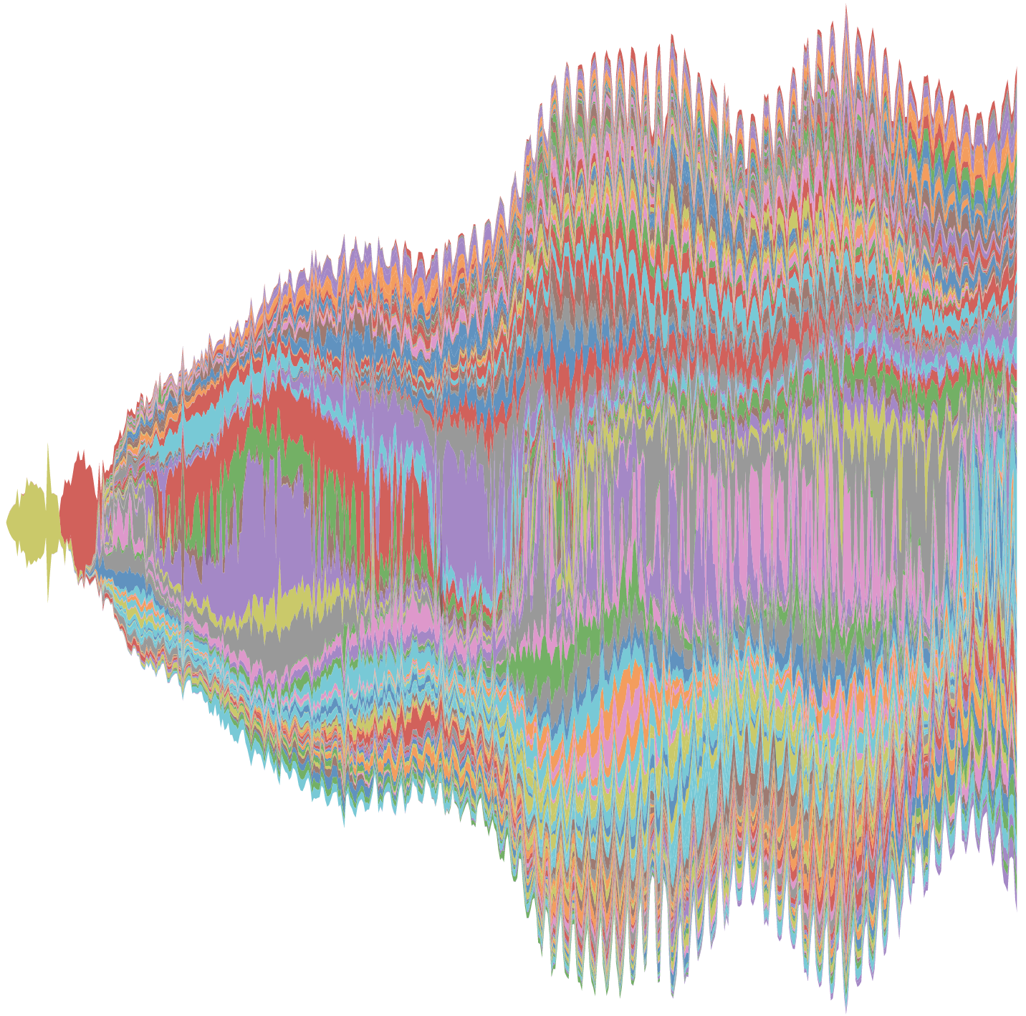

**Figure-5: Colored Streamgraph**

**Description:** This stream graph is filled with color. Each color flow in the graph is named as stream and that represents a country. On mouse hover each stream shows the corresponding country name as tooltip. Intensity of colors do not have any relation with uncertainty. Along x-axis it represents date and y-axis represent the counts.

**12. Select the degree to which you agree or disagree with each of the following statements:**

Appendix C – Questionnaire Module

1. It is very easy to distinguish the flow for each country.

|  |  |  |  |  |
| --- | --- | --- | --- | --- |
| Strongly  agree | Partially  agree | Neither agree nor disagree | Partially  disagree | Strongly  disagree |

1. There are unique colors for each country.

|  |  |  |  |  |
| --- | --- | --- | --- | --- |
| Strongly  agree | Partially  agree | Neither agree nor disagree | Partially  disagree | Strongly  disagree |

1. Identification of some countries are difficult.

|  |  |  |  |  |
| --- | --- | --- | --- | --- |
| Strongly  agree | Partially  agree | Neither agree nor disagree | Partially  disagree | Strongly  disagree |

1. Same color in different stream refers to same country.

|  |  |  |  |  |
| --- | --- | --- | --- | --- |
| Strongly  agree | Partially  agree | Neither agree nor disagree | Partially  disagree | Strongly  disagree |

1. Red and bright colors are easily identifiable and those have higher uncertainties.

|  |  |  |  |  |
| --- | --- | --- | --- | --- |
| Strongly  agree | Partially  agree | Neither agree nor disagree | Partially  disagree | Strongly  disagree |

1. Top streams may have higher uncertainties than bottom stream countries.

|  |  |  |  |  |
| --- | --- | --- | --- | --- |
| Strongly  agree | Partially  agree | Neither agree nor disagree | Partially  disagree | Strongly  disagree |

13. Please provide any additional comments/suggestions you wish the researchers to inform regarding this section.

……………………………………….……………………………………….……………………………………….…………………………………

……………………………………….……………………………………….……………………………………….………………………………

**Texture Streamgraph**

Appendix C – Questionnaire Module

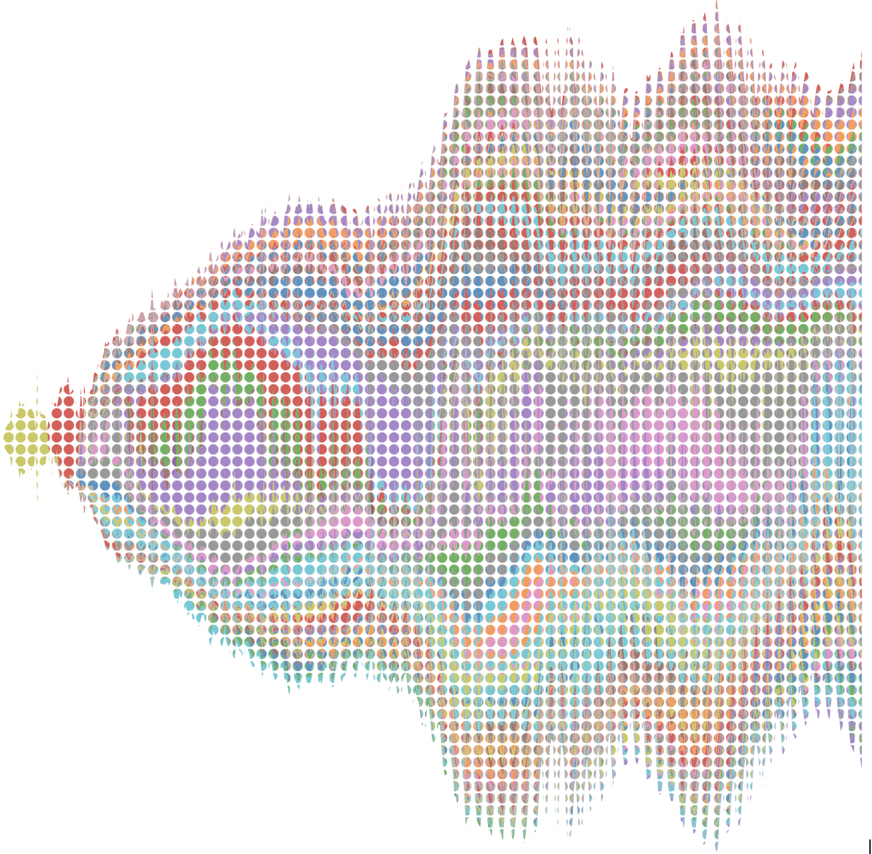

**Figure-6: Streamgraph with textures**

**Description:** This chart is generated from the Figure-5 by just replacing the filling color with textures where still texture maintains colored stream flow. Axes presentations are same as that of colored fill version.

**14. Select the degree to which you agree or disagree with each of the following statements:**

1. The stream gains flow continuity in texture version.

|  |  |  |  |  |
| --- | --- | --- | --- | --- |
| Strongly  agree | Partially  agree | Neither agree nor disagree | Partially  disagree | Strongly  disagree |

1. Difficult to trace aberrated countries here.

|  |  |  |  |  |
| --- | --- | --- | --- | --- |
| Strongly  agree | Partially  agree | Neither agree nor disagree | Partially  disagree | Strongly  disagree |

1. Single bullet doesn’t represent multiple color.

Appendix C – Questionnaire Module

|  |  |  |  |  |
| --- | --- | --- | --- | --- |
| Strongly  agree | Partially  agree | Neither agree nor disagree | Partially  disagree | Strongly  disagree |

1. All country streams start at the same date.

|  |  |  |  |  |
| --- | --- | --- | --- | --- |
| Strongly  agree | Partially  agree | Neither agree nor disagree | Partially  disagree | Strongly  disagree |

1. Overall counts increase with time whereas for some countries it decreases.

|  |  |  |  |  |
| --- | --- | --- | --- | --- |
| Strongly  agree | Partially  agree | Neither agree nor disagree | Partially  disagree | Strongly  disagree |

**15. Please provide any additional comments/suggestions you wish the researchers to inform regarding this section.**

……………………………………….……………………………………….……………………………………….…………………………………

……………………………………….……………………………………….……………………………………….…………………………………

……………………………………….……………………………………….……………………………………….…………………………………

**Starfish layout**

Appendix C – Questionnaire Module

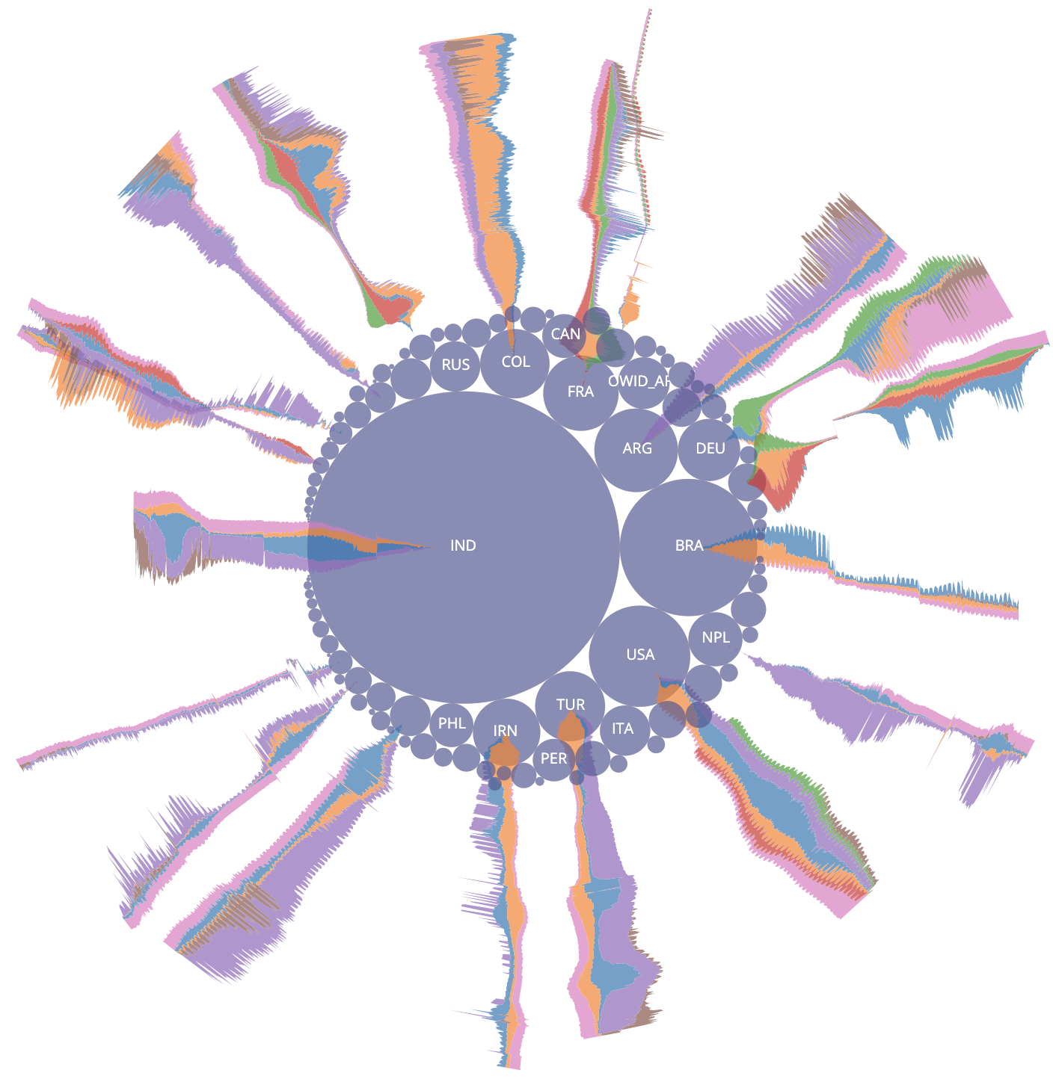

**Figure-6: Bubble chart with star-fish layout**

**16. Select the degree to which you agree or disagree with each of the following statements:**

Appendix C – Questionnaire Module

1. India has smaller stream because it has lower uncertainty.

|  |  |  |  |  |
| --- | --- | --- | --- | --- |
| Strongly  agree | Partially  agree | Neither agree nor disagree | Partially  disagree | Strongly  disagree |

1. Some countries have thinner wing due to higher number of counts and uncertainty.

|  |  |  |  |  |
| --- | --- | --- | --- | --- |
| Strongly  agree | Partially  agree | Neither agree nor disagree | Partially  disagree | Strongly  disagree |

1. Smaller circles do not have bigger stream wing.

|  |  |  |  |  |
| --- | --- | --- | --- | --- |
| Strongly  agree | Partially  agree | Neither agree nor disagree | Partially  disagree | Strongly  disagree |

1. Smaller circles may or may not have bigger stream wings.

|  |  |  |  |  |
| --- | --- | --- | --- | --- |
| Strongly  agree | Partially  agree | Neither agree nor disagree | Partially  disagree | Strongly  disagree |

**17. Please provide any additional comments/suggestions you wish the researchers to inform regarding this section.**

……………………………………….……………………………………….……………………………………….…………………………………

……………………………………….……………………………………….……………………………………….…………………………………

……………………………………….……………………………………….……………………………………….…………………………………

**Parallel Coordinates**

Appendix C – Questionnaire Module

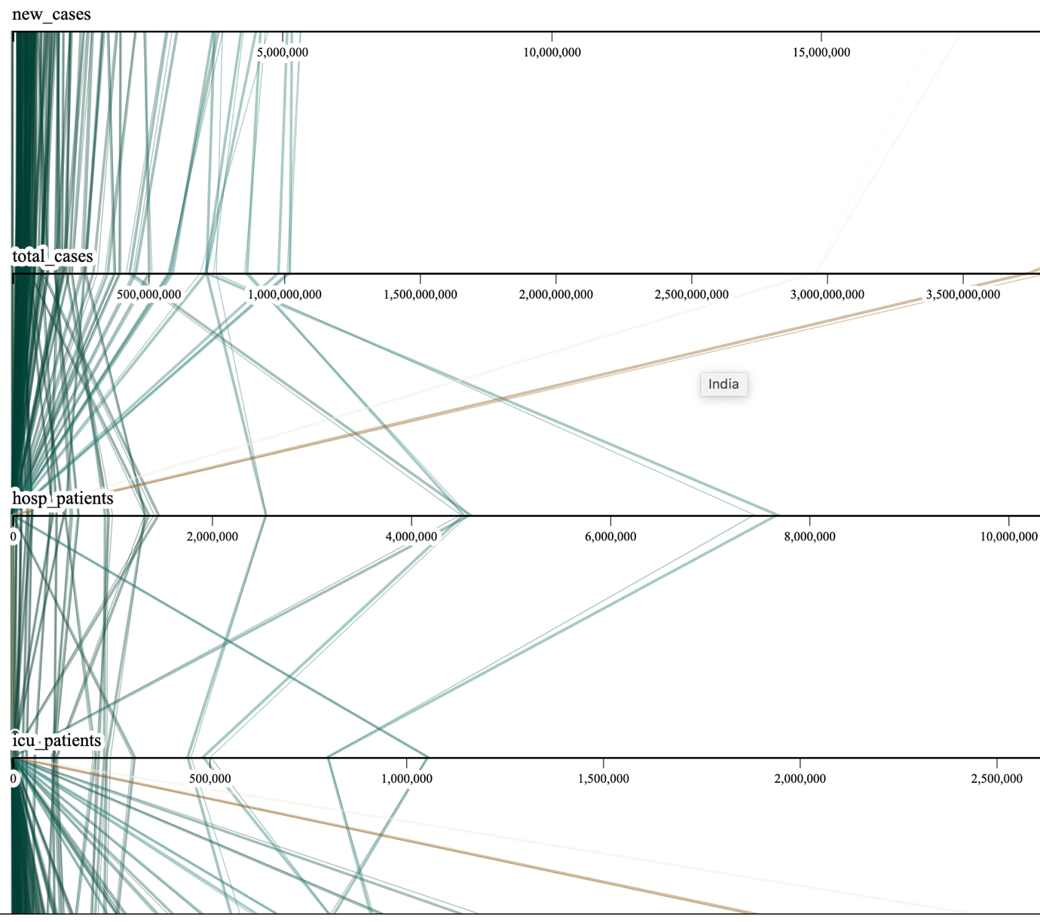

Figure-7: Parallel Coordinate Chart

**Description:** Parallel plots or parallel coordinates plots allows one to compare the features of several individual observations (series) on a set of numeric variables. Each horizontal axis represents a variable and often has its own scale and the units can even be different, that is the strength of this special kind of plots.

**18. Select the degree to which you agree or disagree with each of the following statements:**

1. India has lower uncertainties compared to other countries.

|  |  |  |  |  |
| --- | --- | --- | --- | --- |
| Strongly  agree | Partially  agree | Neither agree nor disagree | Partially  disagree | Strongly  disagree |

1. No countries have ICU patients.

Appendix C – Questionnaire Module

|  |  |  |  |  |
| --- | --- | --- | --- | --- |
| Strongly  agree | Partially  agree | Neither agree nor disagree | Partially  disagree | Strongly  disagree |

1. All countries have Hospitalized patients.

|  |  |  |  |  |
| --- | --- | --- | --- | --- |
| Strongly  agree | Partially  agree | Neither agree nor disagree | Partially  disagree | Strongly  disagree |

**19. Please provide any additional comments/suggestions you wish the researchers to inform regarding this section.**

……………………………………….……………………………………….……………………………………….…………………………………

……………………………………….……………………………………….……………………………………….…………………………………

……………………………………….……………………………………….……………………………………….…………………………………

**Impact Chart**

Appendix C – Questionnaire Module

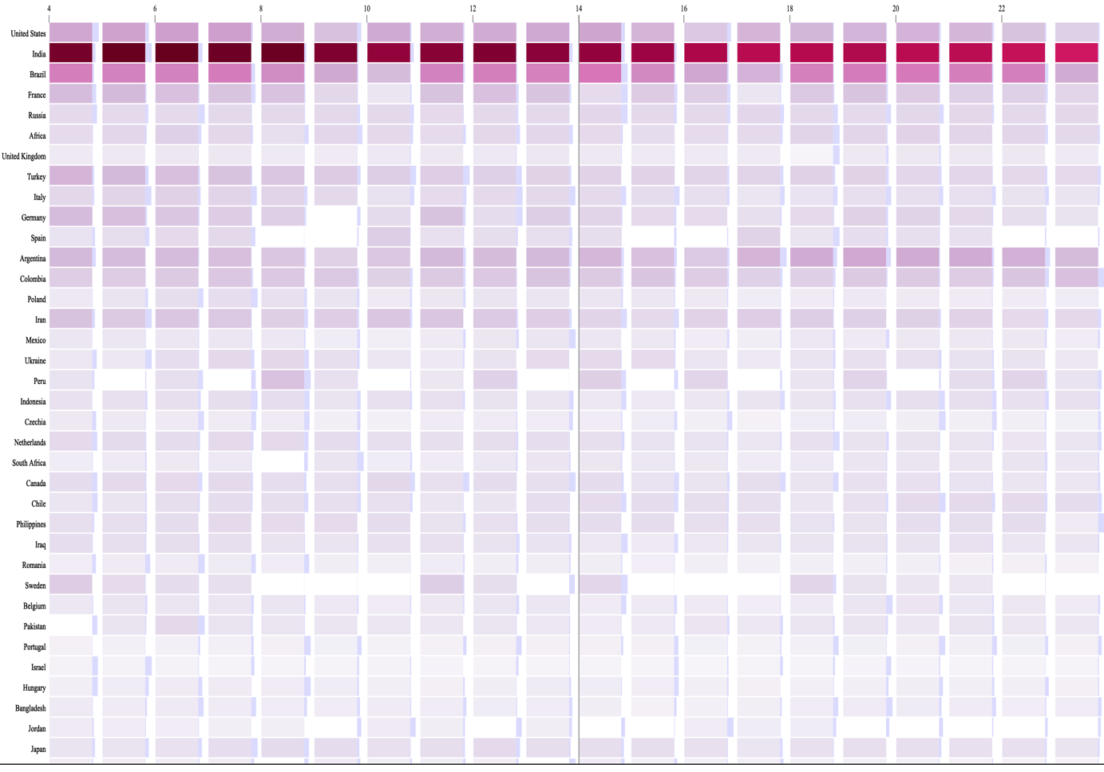

Figure-8: Parallel Coordinate Chart

**Description:** This chart helps to indicate daily uncertainty presentation for every country as a cell. In this way a user can perceive trends for certain day or a set of consecutive days.

**19. Select the degree to which you agree or disagree with each of the following statements:**

1. Uncertainties for United Kingdom are not recognizable for every day.

|  |  |  |  |  |
| --- | --- | --- | --- | --- |
| Strongly  agree | Partially  agree | Neither agree nor disagree | Partially  disagree | Strongly  disagree |

1. Uncertainties for United Kingdom are not recognizable for every day.

|  |  |  |  |  |
| --- | --- | --- | --- | --- |
| Strongly  agree | Partially  agree | Neither agree nor disagree | Partially  disagree | Strongly  disagree |

**Horizontal Chart**

Appendix C – Questionnaire Module

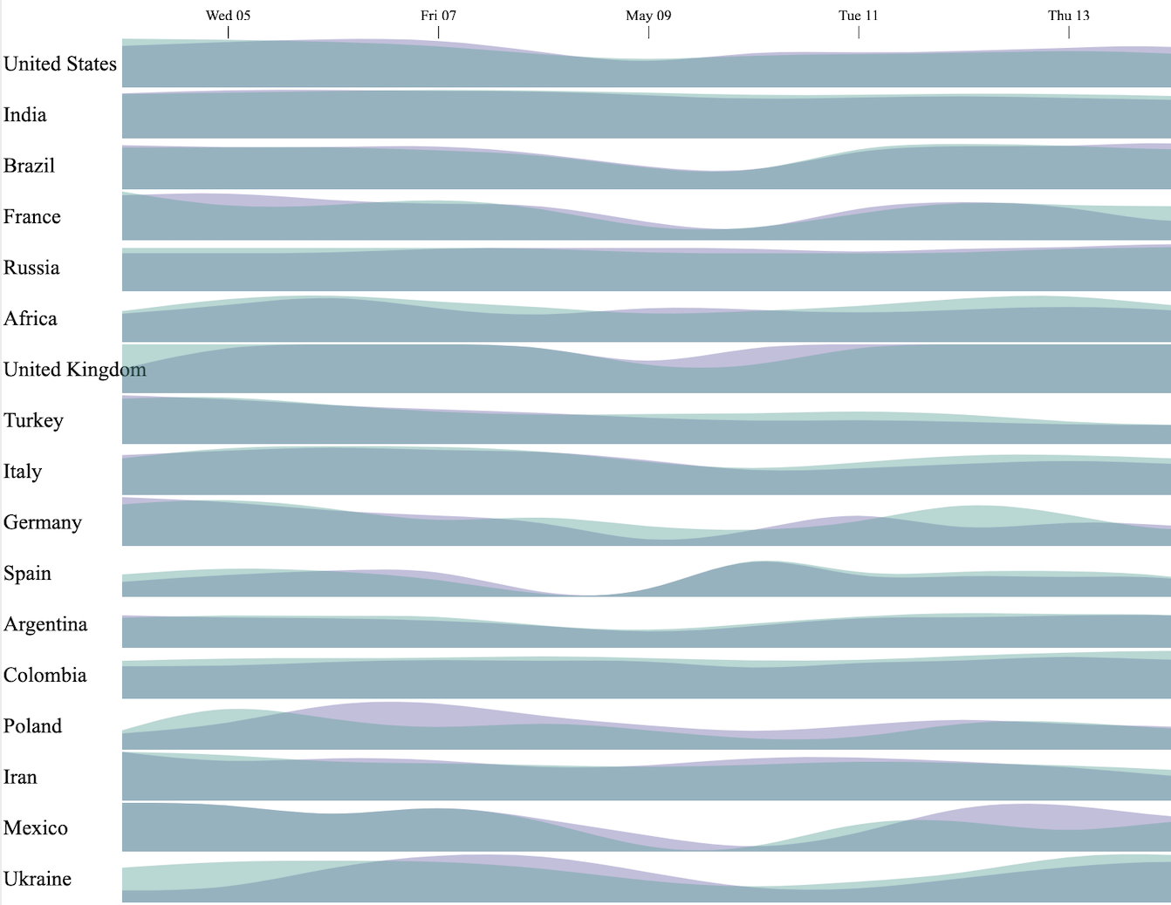Figure-8: Parallel Coordinate Chart

**Description:**

Horizontal charts are small-multiple area charts that allow greater precision for a given vertical space by using colored bands. Uncertainties are represented here by colors other than the green one.

**20. Select the degree to which you agree or disagree with each of the following statements:**

1. Colombia indicates maximum aberration/uncertainty.

|  |  |  |  |  |
| --- | --- | --- | --- | --- |
| Strongly  agree | Partially  agree | Neither agree nor disagree | Partially  disagree | Strongly  disagree |

1. Germany shows little variation of uncertainty.

|  |  |  |  |  |
| --- | --- | --- | --- | --- |
| Strongly  agree | Partially  agree | Neither agree nor disagree | Partially  disagree | Strongly  disagree |

1. Iran has almost constant uncertainty.

Appendix C – Questionnaire Module

|  |  |  |  |  |
| --- | --- | --- | --- | --- |
| Strongly  agree | Partially  agree | Neither agree nor disagree | Partially  disagree | Strongly  disagree |

**21. Please provide any additional comments/suggestions you wish the researchers to inform regarding this section.**

……………………………………….……………………………………….……………………………………….…………………………………

……………………………………….……………………………………….……………………………………….…………………………………

……………………………………….……………………………………….……………………………………….…………………………………

**General Feedback**

**22. Please provide holistic feedback you wish the researchers to inform about the visualization of the whole VUWCA.**

……………………………………….……………………………………….……………………………………….…………………………………

……………………………………….……………………………………….……………………………………….…………………………………

……………………………………….……………………………………….……………………………………….…………………………………

……………………………………….……………………………………….……………………………………….…………………………………

……………………………………….……………………………………….……………………………………….…………………………………

……………………………………….……………………………………….……………………………………….…………………………………